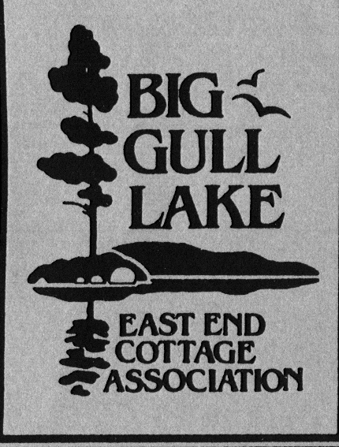

NEWSLETTER,
Volume 24, Number 1, January 31, 2007

Dear Association Members: Welcome to the 2007 cottage season. To date, winter has been strangely absent and some of the lucky cottage owners who can access their property in the winter are wondering whether or not they will be able to snowmoblile, skate, ski, or ice fish on Big Gull. However, we all know that spring will closely follow whatever happens between now and April/May and we will be making our plans to open up the cottage and enjoy our beautiful lake.

Message from the President: Our 2006 Annual General Meeting was held at Phyper’s Marina September 02, 2006. Bill Kuepher and Dave Pattenden made a presentation and led a discussion on the future docking/parking arrangements for Island Cottagers. Strong concern was voiced by several cottagers who are situated near the planned site (adjacent to the Ministry of Natural Resources public boat ramp on the south shore just west of the Community Well). As an update, I have been in touch with Dave Pattenden and he informs me that the site approval process is underway. It will involve a formal application, consultation with the Island Cottagers and other “interested” parties, and an environmental study to be funded by the Island Cottagers.
Reports were given on successful Association events including the “Kids” fish derby, the Golf Tournament, and the annual sailboat races.
Association directors updated the membership on their respective areas of responsibilities and elections were held to fill the following positions: Director at Large, Nancy Gibson; Treasurer, Larry Glass; Environmental Manager, Ken Grant; Secretary, Donna Commerford.
The AGM was followed by a delicious meal of brats, burgers and pot luck dishes hosted by volunteers from Areas 1, 2, and 3. The complete AGM minutes will be posted on our bulletin boards for your information.
I would like to remind you the January Newsletter includes the Dues Sheet for 2007. I am pleased to announce that there will be no increases in dues for the upcoming year. Please take a moment and complete the form and submit your dues. It is vital that we receive the money at the beginning of the season so that we can carry out the plans and programs for the coming year. Your early attention to dues also means that someone does not have to contact you during the summer months about collecting outstanding fees.

Environmental Report:

The Community Well: After many years of providing drinking water to Big Gull Lake East End Cottagers, the lack of use and general interest this past year forced the closure of our community well. The well has been capped by a commercial sealed system which can be reactivated if the need for a community drinking water source should change and a group of sufficient users/volunteers request it.
Fireboat: A number of cottagers expressed interest in having an update on the status of the association’s fireboat which had been sold for a nominal amount to the Plevna Fire Department. The agreement was that the fire department would maintain the boat in working order and have it situated on or adjacent to Big Gull Lake for use on Big Gull Lake fires. I have contacted the Fire chief and he has informed me that they had to repair the firepump on the boat and have had some difficulties in getting the repairs completed. He assured me that they have completed the work and that the fireboat will be functional and ready for next season.
Weed Cutting Service: Some of you may have seen Dave Cox and Ken Grant cutting weeds in several bays this past summer. The Association purchased a “weed sickle” for use by Association members and the service will be available this coming year for a nominal fee. The system can cut weeds around docks and swimming areas down to a depth of 4 feet. Please contact Ken Grant and or Dave Cox for information.
Gypsy Moth Kits: Last year, I introduced a gypsy moth kit to be used for the purpose of monitoring the amount of gypsy moth activity around a cottage. Several cottagers purchased the $12 kit and reported that they had excellent results. I was curious as to whether or not my trap was attracting any gypsy moths and was in the process of opening it up when a gypsy moth landed and entered the trap. At the end of Aug, I opened it and saw that I had trapped more than 50 male moths—that will be 50 moths that could not successfully enter the reproductive cycle for next year. Contact Ken Grant if you are interested.
Oak Leaf Twig Prunner: A number of cottagers contacted me last season about the large number of oak and maple twigs and branch ends which seemed to be falling mid summer. The culprit is the Oak Leaf Twig Prunner which borrows into the twig near the end of the branch and causes the twig to die, leaves to turn brown, and the twig to fall to the ground. I have contacted a biologist from the MNR and they inform me that there is little that can be done to control this insect and that they should not harm a mature tree.
Give Your Shore Line a Make-over: Cottagers are always looking for projects and activities to enhance their properties. Similarly, a lake taken as a whole can become the centre of attention for collective cottage owners.. There are several things that you can do as an individual cottage owner to help ensure that our lake remains healthy and pristine:
- Prune trees rather than removing them; plant low maintenance native trees and shrubs to reduce erosion and absorb runoff.
- Replace solid surfaces with porous materials where possible; redirect runoff into settling areas, away from the water’s edge.
- “Mow it high and let it lie”—leave grass 3 inches high to retain moisture; mulch clippings for fertilizer.
- Start a buffer - leave some grass uncut along the water’s edge; restore with deep rooting native plants.
- Soften you shoreline – improve erosion protection with native trees, shrubs, grasses and aquatic plants.
- Use a well maintained electric motor, or a 4 or 2 stroke engine that meets or exceeds EPA guidelines.
- Replace and properly maintain your septic system - consult an expert.
- Use environment-friendly products, or alternatives like baking soda and vinegar.
For Cottagers who are interested, contact EcoScapes: 602 O’Brien Lake Lane, Maberly, ON K0H 2B0, phone 613-421-6720, an organization that provides landscaping and nursery plants for shore and natural restoration.

Lake and River Temperature Monitoring Project: This past summer approximately 100 volunteers from Mississippi Valley Conservation, the Mississippi Valley Field Naturalists and various lake associations carried out a water temperature survey on the Mississippi River Watershed including 9 sites on Big Gull Lake. A total of 1400 surface water temperature readings were collected, recorded and archived with the MVC, Lanark Office. Average surface water temperatures were 26.4 degrees C and 69% or these readings were between 26 and 27 degrees C. This data will provide one basis for considering the implications of future climate changes. Lake and river temperatures are expected to follow current air temperature trends and increase by at least 3.5 degrees C by 2050.

Interim Walleye Possession and Size Limits: Harold Krieger informs me that the interim walleye possession and size limit has not been passed yet so the 2006 regs still stand at 6 walleye - no size limit for Big Gull Lake. The 2007 regs including the interim walleye possession and size limit (4 walleye - one over 18”) could be put in effect at any time but will follow public notice through the media.

Event Dates for 2007:

Jan 31, 2007 Newsletter and Dues Mailing
April 30, 2007: Calendar distributed
May 19, 2007: Spring Director’s Meeting
May 31, 2007: Spring Newsletter
June 09, 2007: Area Reps Meeting at Ken Grants – 1000 hrs.
July 11, 2007: Golf Tournament
Aug 4 & 5: Sailboat Races
Aug 11, 2007: Kid’s Fishing Derby
Aug 18, 2007: Director’s Meeting at Nancy Kingston’s - 1000 hrs
Aug 25, 2007: North Shore Road Meeting
Sept 01, 2007: AGM and Picnic: 1000 hrs for AGM and 1200 for Picnic
Sept 29, 2007: Director’s Meeting at Ken Grants – 1000 hrs

